Nicolas Katz
Arizona Institutes of Resilience EarthGrant
Collaborative Conservation and Adaptation Strategy Toolbox (CCAST)
2021-2022 Final Report
21 April 2022

Table of Contents

Case Study 1: “Impacts of Herbicide Brush Management on Hydrology & Sedimentation at Walnut Gulch Experimental Watershed” ……………………………………………………………3
Published March 2022 In Collaboration with USDA Agricultural Research Service

CS1 Handout…………………………………………………………………………………………..11

Case Study 2: “Ecological Response to Restored Flows in the Urban Santa Cruz River”……13
Published November 2021 In Collaboration with UA SNRE and Tucson Water

CS2 Handout…………………………………………………………………………………………...22

Notes:
Pink font: replace placeholders
Blue font: for the 2-pager
Red font: optional additional or alternate text that will be used for the online version
Photos Live HERE (Ariel has access)

Impacts of Herbicide Brush Management on Hydrology & Sedimentation at Walnut Gulch Experimental Watershed

March 2022
United States Department of Agriculture Agricultural Research Service
Presented with Support from the U.S. Fish and Wildlife Service, Bureau of Reclamation
Case Study Reviews
Reviewer | Organization | Comments
Larry Fisher | UA | 11/30/21
Maude Dinan | SWCH | 11/30/21
Ariel Léger | UA | 11/30/21
Justin Johnson | ARS | 1/20/22
Jason Williams | ARS | 1/26/22

Background/Introduction (Handout)

Walnut Gulch experimental watershed (WGEW), located in southeastern Arizona, has experienced a proliferation of whitethorn acacia (Vachellia constricta) into historical grasslands. Woody species encroachment can increase runoff and soil erosion, leading to the loss of grassland ecosystem services. Changes in erosion and runoff may prevent establishment of grasses allowing shrub dominance. Herbicides leave shrub skeletons in place and may not cause increased runoff and erosion, however, this remains largely untested. Researchers at the University of Arizona and the Agricultural Research Service assessed impacts of herbicide treatment on vegetation cover, runoff, and sediment loss of a shrub-encroached grassland.

Additional Background/Introduction (ONLINE VERSION, alternate)
Walnut Gulch is an experimental watershed in southeastern Arizona that is managed by the Southwest Watershed Research Center. Walnut Gulch has experienced an increase of whitethorn acacia (Vachellia constricta), a common native woody shrub, into areas that were historically dominated by native grasses. Shrub encroachment often leads to larger patches of bare ground, increased erosion, and reduced infiltration. This can start a cycle of degradation leading to the loss of grasslands and the ecosystem services they provide. Between 2008 and 2018, Walnut Gulch was treated with the herbicide tebuthiuron (‘spike’) over 22% of its area to reduce whitethorn acacia and other woody plant cover.

The increase of woody plants like whitethorn acacia into historical grasslands can result from the interactions of less frequent fires, livestock overgrazing, increases in atmospheric carbon dioxide, and climate change-driven drought and heat waves, among other factors. The conversion of grassland ecosystems has important ecological and economic consequences, including the loss of fertile topsoil, vegetation cover, and associated habitat and forage values.

Shrub management strategies like herbicide treatments seek to reduce woody plant cover to allow for the recovery of grasslands. However, field studies of the impacts of herbicide treatment on runoff and sedimentation of shrub-encroached grasslands are lacking. An understanding of the impacts of treatment on the runoff and sedimentation processes which reinforce the transition to shrubland ecosystem states may allow managers to assess the potential for recovery of grasslands using herbicides.

Researchers at the University of Arizona and at the Agricultural Resource Service used field rain simulations, modeling approaches, and assessments of physical landscape attributes to compare runoff, sediment loss, and vegetation cover on Limy Slopes ecological sites at Walnut Gulch.

Key Issues Addressed (Handout)
In shrublands, patches of bare ground are larger and more connected than in grasslands, allowing greater movement of water and sediment. These resources can become depleted in between ‘resource islands’ that form when fertile soil accumulates around shrubs. The disparity in water and soil retention between resource islands and surrounding bare ground (interspaces) advantages shrubs over grasses, reinforcing the transition to shrubland ecosystem state.

While herbicides are commonly used for shrub management, more field studies are needed to determine if herbicide treatment of shrub encroached grasslands can interrupt the runoff and sedimentation processes that reinforce shrubland conversion.

Key Issues Addressed (ONLINE VERSION, alternate)
In shrublands, patches of bare ground are often larger and more connected than in grasslands, allowing greater movement of water and sediments. Increased soil erosion and reduced infiltration capacity causes the spaces between shrubs to become depleted of these resources. As fertile soil accumulates around the bases of shrubs, ‘resource islands’ form.

The formation of resource islands advantages shrubs and reinforces the transition to shrubland ecosystem states. Grasses are unable to establish in the resource-depleted spaces between soil-accumulating shrubs, allowing spatially disparate resource accumulation and depletion to continue. Shrub management actions like herbicide treatment seek to remove woody plants and halt this accumulation of resources. Although herbicides have been employed widely as a brush management technique, field studies on the impacts of herbicide treatment on runoff and sedimentation processes of shrub-encroached grasslands are lacking.

Common practices to reduce woody plant cover include prescribed fire and mechanical removal techniques like grubbing and chaining. While these may be effective in reducing woody species abundance, they may increase the amount of bare ground by removing the shrub skeleton. As a result, already heightened runoff and sediment loss may be exacerbated initially. In contrast, herbicide treatments that leave the skeleton of the shrub intact may minimize runoff and erosion. While herbicides are an effective tool used widely to reduce shrub cover, uncertainties remain as to the efficacy of herbicide treatments in preventing amplification of runoff and erosion following treatment.

Project Goals (Handout)
- Compare vegetation cover, runoff, and soil loss between herbicide-treated and untreated sites across spatial scales five years after treatment
- Assess if resource accumulation in resource islands is disrupted in treated sites
- Determine which structural characteristics of soil and vegetation are reliable indicators of erosion and runoff vulnerability

Project Goals (ONLINE VERSION, alternate)
- Compare vegetation cover, runoff, and soil loss between herbicide-treated and untreated sites
- Determine if changes in runoff and soil loss following herbicide treatment disrupt the accumulation of resources in resource islands, allowing for the redistribution of soil nutrients and increased infiltration capacity in interspaces
- Assess whether impacts to vegetation, runoff, and soil loss vary across spatial scales
- Assess which structural characteristics of soil and vegetation are reliable indicators of runoff and erosion vulnerability

Project Highlights (Handout)
- Grasses Rebound: Grass cover increased in interspaces and resource islands on treated sites, leading to an overall increase in grass cover from 13% to 61%. Shrub cover was reduced from 40% on untreated sites to less than 1% on treated sites. This marked a transition back to grass dominance on treated sites.
- Reduced Runoff and Erosion in Resource Islands: On treated sites, runoff and soil loss were reduced by 72% and 88% respectively in resource islands at fine scales. Infiltration rates, runoff, and sediment loss were similar in interspaces across sites.
- Hillslope Scale Impacts: Researchers paired rainfall simulations and overland flow experiments, which provide insights at fine and coarse scales, respectively, with the hillslope-scale Rangeland Hydrology and Erosion Model (RHEM). At the hillslope scale, erosion was reduced in treated sites while runoff was unchanged.
- Basal Gaps Predict Cumulative Runoff and Sediment Yield: Basal gap length (the distance between plant bases) predicted runoff and sediment loss, where short lengths were correlated with limited runoff and erosion. This supports the use of basal gap length as a method for assessing impacts of treatments.

Project Highlights (ONLINE VERSION, alternate)
- Highlight for Call-Out Box, Project Highlights
Long-Term Hydrologic Data: The Southwest Watershed Research Center houses datasets of precipitation, sedimentation, and runoff for WGEW dating back to the 1950s.
- Grasses Rebound: Grass cover was greater on treated sites compared to untreated sites. At the fine scale, grass cover in interspaces increased from 0% in untreated sites to 25% in treated sites, and from 12% in the canopy of untreated sites to 75% in treated sites. Grass cover similarly increased at the coarse scale from 13% on untreated sites to 61% on treated sites. Increases in grass cover led to an overall increase in vegetation cover from 56% to 78% at the coarse scale, and shrub cover was reduced from from 40% on untreated sites to less than 1% on treated sites. This marked a transition back to grass dominance on treated sites.
- Reduced Runoff and Erosion in Resource Islands: At high rainfall intensities (100 and 120mm/hr) runoff in resource islands on treated sites was reduced by 70-80% when compared with untreated sites at the fine scale. Reductions in runoff led to a similar reduction in erosion. Soil loss in resource islands was 86-88% less on treated sites than untreated sites. Infiltration rates, runoff, and sediment loss were similar in interspaces between treated and untreated sites.
- Hillslope Scale Responses: Researchers paired rainfall simulations which provide insights at fine (0.5m² plots) and coarse (2m x 4.5m plots) scales with the hillslope-scale Rangeland Hydrology and Erosion Model to compare treatment impacts across scales. At the hillslope scale, erosion was reduced across rainfall intensities in treated sites. Runoff, however, showed no difference between treated and untreated sites.
- Basal Gaps Predict Cumulative Runoff and Sediment Yield: The length of basal gaps (the distance between plant bases) predicted the amount of runoff and erosion across study sites. Short basal gap lengths limited cumulative runoff and sediment yield, while larger basal gap lengths were correlated with increased cumulative runoff and sediment yield. This indicates that the size of continuous bare ground patches is a determinant of runoff and sediment loss and supports the use of basal gap length as a method for assessing impacts of treatments.

Lessons Learned (Handout)
The site treated with tebuthiuron generally had less runoff and erosion, and more grass cover than untreated sites. These changes were concentrated in resource islands rather than interspaces. Limited responses to treatment in interspaces may indicate that the underlying feedbacks that maintain shrub-dominance were not interrupted by herbicide treatment.

Linking costly field rainfall simulations with RHEM allowed researchers to compare results across broader scales. RHEM is a low-input (e.g., cover, soil texture, slope) tool available to managers to assess the impacts of shrub removal without complex field experiments.

Following treatments, sites were dominated by nonnative Lehmann Lovegrass and native Bush Muhly (Muhlenbergia porteri). Although Lehmann Lovegrass expanded into interspaces between shrub microsites, interspaces were still vulnerable to runoff and erosion five years following treatment.

Lessons Learned (ONLINE VERSION, alternate)
Five years after tebuthiuron herbicide, it is unclear whether the processes driving woody plant encroachment were adequately disrupted to enable long-term grassland recovery. Sites treated with tebuthiuron were characterized by reduced runoff, reduced erosion, and increased vegetative cover of grasses. Contrary to expectations, changes in runoff and erosion were concentrated in the resource islands under shrub skeletons rather than in the interspaces between them. The limited response to treatment observed in interspaces between shrubs may indicate that the underlying feedbacks that maintain shrub-dominance were not interrupted by herbicide treatment. It is unknown whether the increasing herbaceous cover and subsequent reduction of bare ground will lead to homogenization of resources over the long term, allowing for grassland recovery.

Linking costly field rainfall simulations (which require a rainfall simulator) with the Rangeland Hydrology and Erosion Model (RHEM) allowed researchers to compare changes in runoff and erosion across spatial scales. RHEM is a low-requirement tool available to managers to assess the impacts of shrub removal on runoff and sedimentation without the use of complex and expensive field simulations. By integrating user inputs of soil attributes, ground and foliar cover, and slope dimensions, RHEM allows users to assess impacts of treatment on runoff and sedimentation of a potential treatment area.

Treated sites were vegetated by Lehmann lovegrass (Eragrostis lehmanniana) and Bush Muhly (Muhlenbergia porteri). Nonnative Lehmann lovegrass was only observed on treated sites, leading researchers to speculate that its expansion is limited in part by shrubs. Researchers additionally note that the shift back to grass dominance may not have occurred in the absence of Lehmann lovegrass. Although this bunchgrass expanded into interspaces, these areas retained vulnerabilities to runoff and erosion. Native grasses may not have the same capacity to grow into these resource-poor interspaces. At Walnut Gulch, herbicide treatments initiated a shift to a grassland dominated by Lehmann lovegrass five years following treatment.

Next Steps (Handout)
- Assess long-term outcomes to determine the stability of observed changes
- Assess impacts of herbicide treatment at the watershed scale
- Assess interactions between treatment outcomes and disturbances, like fire
- Investigate the role of macropores (large pores in soil allowing infiltration) that likely mediated the different infiltration response between interspaces and resource islands

Next Steps (ONLINE VERSION, alternate)
- Future research should aim to determine the long-term impact of herbicide treatments at Walnut Gulch to assess if observed increases in herbaceous cover will lead to resource homogenization over time.
- Future research is needed to determine how immediate outcomes of herbicide treatment, particularly the expansion of Lehmann Lovegrass, interact with ecosystem disturbances like fire to influence site conditions in the long term.
- Researchers note that macropores (large pores in soil allowing infiltration) likely played an important role in mediating the different response observed between interspaces and resource islands. Future research should aim to examine the mechanistic role of macropores in infiltration around the skeleton of herbicide-treated shrubs.
- While this research traversed fine to hillslope spatial scales, researchers note that the results of herbicide treatment on water and sediment movement at the watershed scale may vary and should be researched further.
- Water is not the only vector of sediment transport and may have influenced the trends observed in this study. Future research should aim to characterize more directly the influence of wind on sediment movement following herbicide treatment.

Collaborators
- Justin Johnson, ARS
- Jason Williams, ARS
- Kelly Young, Cowan Ranch

Funding Partners
- U.S. Department of Agriculture, Agricultural Research Service, Southwest Watershed Research Center (USDA - ARS - SWRC)
- Arizona Agricultural Experiment Station
- This research was a contribution from the Long-Term Agroecosystem Research (LTAR) network. LTAR is supported by the U.S. Department of Agriculture.

Resources
- March 2022 Case Study Handout
- The Rangeland Hydrology and Erosion Model (RHEM)
  - RHEM documentation
- Walnut Gulch Experimental Watershed (WGEW)
- SWRC Data Access Project
- Johnson, J.C., et al. (2022) "Restoration of a shrub-encroached semi-arid grassland: Implications for structural, hydrologic, and sediment connectivity." Ecohydrology 14(4):1-20

Photo Gallery
Photo Album and Credits

Contacts (only first/primary will be included on 2-pager)
- Justin Johnson, justin.johnson3@usda.gov
- Jason Williams, jason.williams@usda.gov

Case Study Lead Author
- Nicolas Katz, University of Arizona

Suggested Citation
Katz, N.A. (2022). “Impacts of Herbicide Brush Management on Hydrology & Sedimentation at Walnut Gulch Experimental Watershed”. CCAST. Retrieved from https://arcg.is/OzaXG1

Tags
desert, grassland, climate change, drought, erosion, invasive, restoration, vegetation, hydrology, watershed, working lands, invasive plants

Filters
Topic: Actionable Science.
Stressor: Native and Non-Native Invasive Species.
Management Strategy: Restoration.

Alt Text for Introduction Tab Map:

Walnut Gulch Experimental Watershed

Suggested photos for online Case Study:
- Photo 1 (Key Issues): Whitethorn Acacia at Walnut Gulch
- Photo 2 (Project Highlights): Rainout Simulator
- Photo 3 (Lessons Learned): Spike Treatment
- Photo 4 (Next Steps): Untreated Plots
- Photo 5 (Resources): Dye Bucket Dump

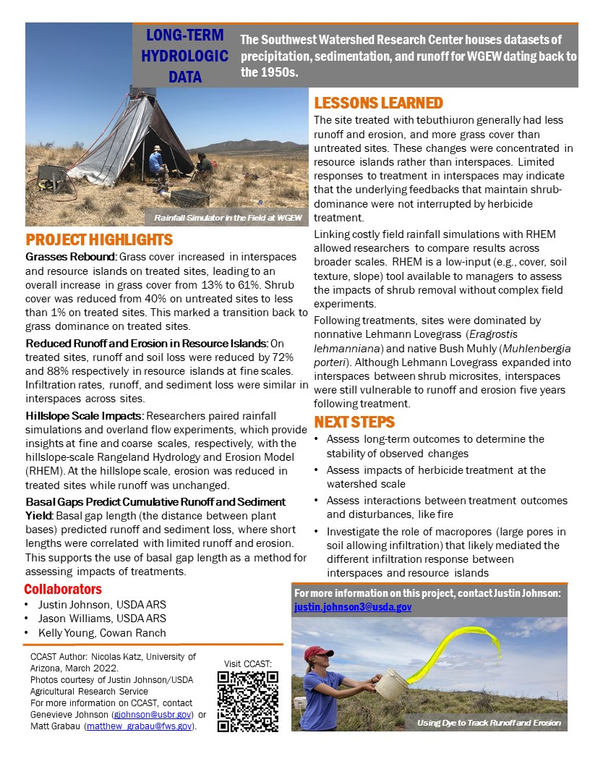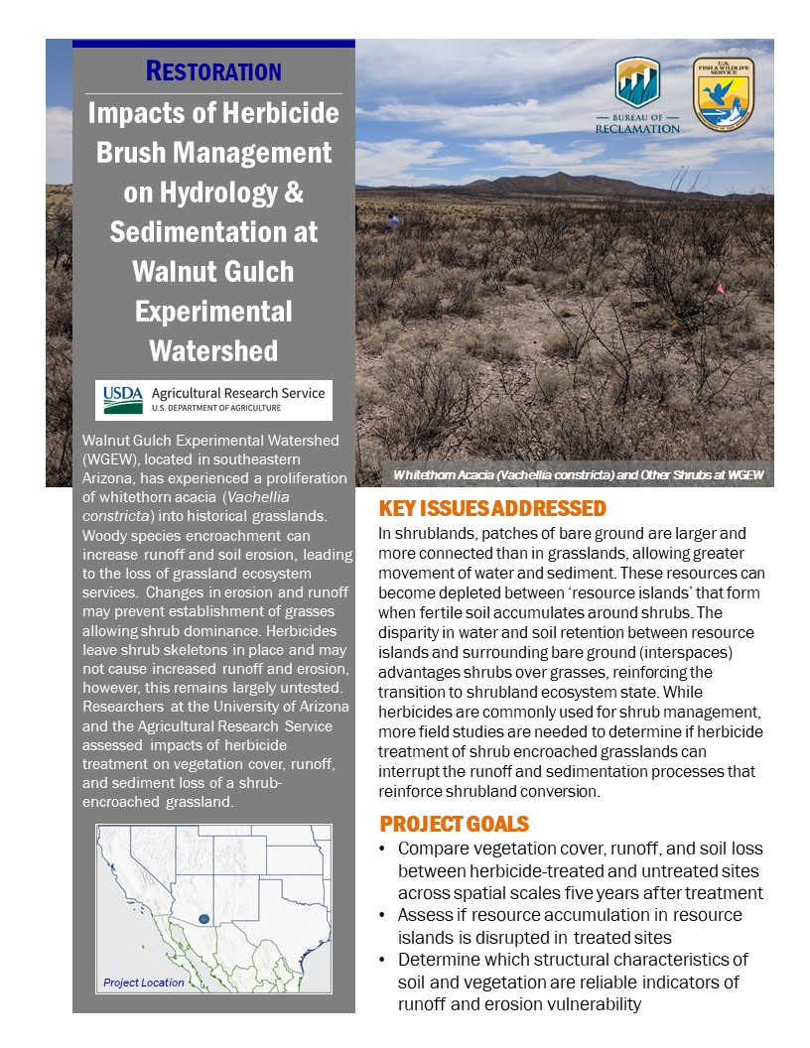

Notes:
Ecological Response to Restored Flows in the Urban Santa Cruz River

Updated [November 2021]
Presented with Support from the U.S. Fish and Wildlife Service, Bureau of Reclamation

Case Study Reviews
Reviewer | Organization | Comments
Anna Weinberg | UA | 7/7/21
Ariel Léger | UA | July 7th 2021
Krystie Miner | UA | 7/8/21, in doc. Nice job!
Betsy Grube | AZGFD | 6/30/21
Maya Teyechea | Tucson Water | 08/10/2021
Michael T. Bogan | Bogan Lab | 8/10/21
Amanda Webb | Pima County | 8/24/21, in doc

Background/Introduction (80-90 words)
Most river systems in the American Southwest have suffered reduced, lost, or increasingly variable flows. Common drivers include dams/diversions, groundwater pumping, land use change, and reduced flows due to climate change. The Santa Cruz River originates in southeastern Arizona and flows through the city of Tucson. Loss of flows in the river led to decline or extirpation of most of its historically present native aquatic and riparian species. In 2019 Tucson Water, the city’s water managers, began using reclaimed water to return flows to the Heritage Reach (‘the reach’) of the Santa Cruz River near downtown Tucson. Researchers studying the restored flows noted expedient ecological responses.

Additional Background/Introduction (Online, alternate )

The Santa Cruz River originates in southern Arizona, where it flows south across the Mexican border before curving northward and back into the United States. The city of Tucson developed in the floodplain of the Santa Cruz River and is now a major urban center. The Heritage Reach (‘the reach’) of the Santa Cruz, named for its historical and cultural significance to the region, runs through downtown Tucson.

Historically, the Santa Cruz River flowed perennially in several sections and served as important habitat for multiple species that are now threatened, endangered, or extinct. Historical fish assemblages in the Heritage Reach included Longfin Dace (Agosia chrysogaster), Santa Cruz Pupfish (Cyprinodon arcuatus, now extinct), Gila Chub (Gila intermedia), and Gila Topminnow (Poeciliopsis occidentalis). Additionally, lowland leopard frog (Rana yavapaiensis), Northern Mexican gartersnake (Thamnophis eques megalops), Huachuca water umbel (Lilaeopsis schaffneriana var. recurva), and California floating mussel (Anodonta californiensis) all occurred in the Santa Cruz River basin, and are now threatened, endangered, or in decline in the region.

In 2013, the Pima County Regional Wastewater Reclamation Department constructed the Agua Nueva Water Reclamation Facility to replace former treatment facilities. The Agua Nueva facility produces effluent that is safe for all uses excluding body-contact recreation and consumption. In 2016, the city of Tucson’s water management agency, Tucson Water, began discussing restoring flow to the Heritage Reach of the Santa Cruz River through the use of reclaimed water from the Agua Nueva treatment facility, giving rise to the Heritage Project. Tucson Water set out to recharge the downtown aquifer, earn long term storage credits (LTSCs), and restore the cultural, social, and economic value of the Santa Cruz River.

In 2019, Tucson Water started releasing treated effluent into the Heritage Reach to reintroduce river flows. Researchers at the University of Arizona began to monitor the reach following a rapid positive ecological response to rewatering. Restored flows in the Heritage Reach have provided novel habitat for native species that quickly recolonized, or were reintroduced to, the previously dewatered urban river section.

Key Issues Addressed (Handout)

The Santa Cruz River was widely dewatered across most of its perennial reaches by 1940 due to development in the basin. Subsequent habitat loss led to the extinction of the Santa Cruz Pupfish (Cyprinodon arcuatus) and contributed to the decline of other species like the Gila Topminnow (Poeciliopsis occidentalis).

The Southwest is expected to experience greater drought intensity and warmer temperatures due to climate change that may exacerbate habitat loss. Managed urban ecosystems are likely to play an increasingly important role in biodiversity conservation. However, the potential benefits of rewatering urban rivers, and best practices for their management, are not yet well understood.

The Heritage Project is a managed urban ecosystem that provides drought-resistant habitat for native species and an example for future rewatering projects.

Key Issues Addressed (ONLINE VERSION, alternate)
The Heritage Reach flowed perennially before the 1900s. Groundwater depletion, diversions, and arroyo downcutting (erosive alteration of streambeds into deep, channelized incisions) in the late 1880s caused the river to lose perennial flow by 1913. By 1940 the river and its shallow aquifer were dewatered, and it has flowed only during flood events since.

The Santa Cruz historically supported a rich riparian corridor of cottonwood, mesquite, and willow woodlands along the river’s banks. This corridor provided habitat for hundreds of species of migratory birds, aquatic invertebrates, amphibians, reptiles, fish, and other wildlife. This habitat was lost as flows diminished and Tucson was built in the historic floodplain. Loss of flows directly led to the extinction of at least one endemic species, the Santa Cruz Pupfish, and contributed to the decline of other native species, including endangered Gila Topminnow. Dewatering of the Santa Cruz River further led to the loss of economic and recreational opportunities and important cultural resources.

Increasing urbanization along the Santa Cruz River basin has lowered the water table and added to habitat loss and fragmentation in the region, leading to reduced biodiversity. As drought frequency, duration, and severity increase due to climate change, the compounding loss of habitat is likely to adversely impact native plants and wildlife. Additionally, as climate change reduces water availability, demand for groundwater is likely to increase. Therefore, managed urban aquatic ecosystems are likely to play an increasingly important role in the conservation of native species and in storing groundwater for future use in the American Southwest. However, the potential benefits of, and management best practices for, highly modified urban aquatic ecosystems are not yet well understood.

The Heritage Project is an adaptively managed urban ecosystem that provides drought-resistant habitat for native species and serves as an example for future rewatering projects in the Southwest.

Project Goals (Handout)
- Improve habitat availability for native species
- Provide novel habitat for species of conservation concern
- Monitor and adaptively manage the reach to inform ecological knowledge of, and produce best management recommendations for, urban rewatering efforts

Project Goals (ONLINE VERSION, alternate)
- Use existing infrastructure and reclaimed water to restore flows in the previously dewatered Heritage Reach of the Santa Cruz River: Tucson Water sought to recharge the local aquifer through in-stream water allocations, earn long-term storage credits, and increase the social, economic, and cultural value of the river.
- Monitor, record, and adaptively manage the Heritage Reach in order to inform ecological knowledge of urban rewatering projects and provide a framework for developing management recommendations for future urban rewatering initiatives: Researchers working closely with Tucson Water set out to use the Heritage Project as an opportunity to study the ecological benefits of the use of reclaimed water to restore flows in an increasingly urban and arid environment.
- Provide habitat for species of conservation concern: Managers at Arizona Game and Fish Department (AZGFD) and US Fish and Wildlife Service (USFWS) set out to use the new habitat afforded by the Heritage Project for the conservation of Gila Topminnow.
- Improve habitat availability for native species to mitigate the impacts of increasing regional drought: The Heritage Reach is a highly modified and managed ecosystem consisting of a new assemblage of species and interactions. Managers quickly recognized the potential for this establishing ecosystem to provide novel habitat for native species. To meet conservation goals, water managers sought to build upon relationships with local conservation organizations including Tucson Audubon Society and the Sonoran Institute as well as state and federal wildlife agencies.

Project Highlights (Handout)

- Ecological Response and Monitoring: Shortly after flows were returned, University of Arizona researchers began monitoring the response of vegetation, birds, invertebrates, and other wildlife in the reach through visual surveys, camera traps, and citizen science initiatives. Within three hours of the initial water release, seven species of dragonfly and damselfly were observed in the reach. Additionally, three toad species and one snake were observed shortly after rewatering, and species diversity continues to increase with time.
- Topminnow Reintroductions: Managers at the Arizona Game and Fish Department and the U.S. Fish and Wildlife Service enrolled the Heritage Reach into a Safe Harbor Agreement under the Endangered Species Act, allowing the reintroduction of Gila Topminnow to the reach. The first reintroductions occurred in October 2020.
- Drought-Resistant Habitat: Managers at Tucson Water made the Heritage Reach a priority for water allocation given the importance of the habitat it now provides. Because the reach is fed by effluent from the City of Tucson, it is unlikely to be adversely affected by drought in the future.

Project Highlights (ONLINE VERSION, alternate)

Highlight for Call-Out Box
  - Don’t Dread Dredging: In 2020, managers and researchers constructed and maintained an artificial wetland to help aquatic species return to the Heritage Reach after sediment dredging took place to reduce flood risks.

- Recharge Credits for Future Use: As part of Arizona’s 2019 Drought Contingency Plan new policy was instituted which increased previous long-term storage credit rates for effluent from 50% to 95%, meaning that now 95% of the total volume of water recharged by Tucson Water through the Heritage Project will be available for future use during periods of high demand.
- Ecological Response and Monitoring: Shortly after flows were returned, researchers at the University of Arizona began monitoring the response of vegetation, birds, invertebrates, and other wildlife in the reach through visual surveys, camera traps, and citizen science initiatives. Within three hours of the initial release of water, seven species of dragonfly and damselfly were observed in the Heritage Reach. Four months after rewatering, 37 species of dragonfly and damselfly were present in the reach, representing 75% of the known species present in lower sections of the Santa Cruz River. Additionally, three toad species and one snake were observed shortly after rewatering, and species diversity in the reach continues to increase with time.
- Topminnow Reintroductions: Gila Topminnow collected from southern sections of the Santa Cruz River were reintroduced into the Heritage Reach in October 2020, following the enrollment of the site into the Safe Harbor Agreement through a Certificate of Inclusion. Managers at Arizona Game and Fish Department and the US Fish and Wildlife Service quickly recognized the rewatered reach as a resource for conservation of species of concern, and worked with Tucson Water to enroll the site into the Safe Harbor Agreement.
- Drought-Resistant Habitat: Because the Heritage Reach is now fed by effluent and is no longer dependent on floods, it will likely not be adversely affected by future drought. Managers at Tucson Water have identified maintenance of flows in the reach as a high priority, especially following the reintroduction of Gila Topminnow. For this reason, flows are expected to be maintained during periods of drought. Because water use in the City of Tucson remains constant during drought periods, ample effluent is expected to be provided in order to maintain flows.

Lessons Learned (Handout)
Diverse native taxa quickly recolonized the Heritage Reach following rewatering. Managers suspect that the reach was particularly attractive to dispersing individuals because rewatering occurred in a drought year, and nearby riparian habitat is sparse. Nonnative vegetation and aquatic species pose an ongoing management challenge in the Heritage Reach.

Managers found inclusion of the public to be critical to the success of the Heritage Project. Efforts to increase public engagement in the Heritage Project increased after a large turnout at the rewatering ceremony. Public engagement was facilitated through social media, collaboration with local conservation organizations, and direct communication through in-person events like public hearings.

A diverse set of stakeholders are now involved in the Heritage Project. Managers suggest that establishing a list of potential collaborators early on, utilizing existing relationships to meet goals, developing short- and long-term goals, and vision planning across timescales were critical steps taken to ensure the success of the project.

Lessons Learned (ONLINE alternate)

Following the restoration of flows to the Heritage Reach, diverse native taxa quickly returned to the reach. Managers suspect that the reach was particularly attractive habitat for native species because rewatering occurred in a drought year, and nearby riparian habitat is sparse. Although some revegetation efforts have been made in the reach (approximately 30 individual plants were planted by Harris Environmental, a biological consulting group, under contract with Tucson Water), vegetation communities along the river are still primarily composed of species that disperse readily. Nonnative vegetation including Tamarix spp., bermuda grass, buffelgrass (Cenchrus ciliaris), and Johnson grass (Sorghum halepense), and nonnative aquatic species including western mosquitofish (Gambusia affinis) and American bullfrog (Lithobates catesbeinas) pose ongoing management challenges in the Heritage Reach.

Managers of the Heritage Project found that inclusion of the public was integral to its success. Tucson Water hosted public hearings and met with private landowners to conduct water quality surveys in order to address concerns about the water’s safety and increase awareness of the project. Efforts to increase public engagement in the Heritage Project increased after a large turnout at the rewatering ceremony. Social media has since played an important role in facilitating public participation. Now, volunteer efforts to clean up the basin and remove invasive species occur commonly under the facilitation of local conservation groups.

The Heritage Project now includes multiple agencies, organizations, and academic institutions. Managers found that establishing a list of potential contributors early on in the project was key to its success. Leveraging existing relationships allowed for quick progress when developing conservation programs like the enrollment of the site into the Gila Topminnow Safe Harbor Agreement. Identifying and communicating achievable short-term and long-term (>5 years) goals and vision planning across time scales were important steps to securing project success.

Ongoing communication between management and research partners and the public has allowed effective adaptive management of the reach. Managers of the Heritage Project suggest that the modified floodplain, urbanized surrounding environment, restricted potential for natural colonization, and limitations caused by flood control prevent the Heritage Reach from being fully restored to a historical stable community. Instead, they suggest that the reach operates as an “urban garden,'' wherein the Tucson community is heavily encouraged to take an active role in managing the reach through stewardship and monitoring.

Next Steps (handout)
- Continue ecological monitoring of the Heritage Reach, including monthly plant, aquatic insect, bird, and wildlife surveys.
- Develop a full list of historical ecological communities of the Heritage Reach to inform future reintroductions
- Continue public engagement with and stewardship of the Heritage Reach

Next Steps (ONLINE alternate)
- Continue to recharge the downtown aquifer: Tucson Water aims to continue to recharge the downtown aquifer via the Heritage Project and other managed and constructed recharge projects. Through these recharge projects, Tucson Water will provide future reserves of water and earn long-term storage credits which allow them to provide this stored water to their constituents in the future.
- Continue ecological monitoring of the Heritage Reach: Monitoring will include monthly plant, aquatic insect, bird, and wildlife surveys. AZGFD will monitor the success and viability of the reintroduced Gila Topminnow population annually, and make management recommendations according to their findings. Monitoring may also be used to develop best practices for rewatering and management of urban rivers in the Southwest.
- Reintroduce native species: Tucson water will continue to consider active restoration of native vegetation that will not compromise flood risk mitigation efforts in the river basin.
- Develop lists of historic flora and fauna: Researchers at the University of Arizona are working on a formal reconstruction of the native flora and fauna of the Santa Cruz River in the downtown Tucson region. Historical reconstructions will better inform future restoration efforts in the Santa Cruz River basin.
- Continue public engagement and outreach: Tucson Water, University of Arizona researchers, and AZGFD are continually working to develop stronger public engagement with the Heritage Project through signage discouraging the release of nonnative species, social media coverage of the river’s recovery, and partnership building with local organizations.
Collaborators Partners that actively contributed to the project.
- City of Tucson, Tucson Water
- Michael T. Bogan, SNRE, University of Arizona
- Arizona Game and Fish Department

Funding Partners (optional) Use this section to acknowledge where funding was obtained for the project.
- City of Tucson, Tucson Water

Resources
Reports, presentations, etc. (with links to where those can be found)
- November 2021 Case Study Handout
- Tucson Water Heritage Project
- Santa Cruz Valley National Heritage Site Webpage
- Video: Reviving the Santa Cruz with Dr. Michael Bogan
- Santa Cruz River Heritage Project Birds: What We’ve Learned in a Year
- The Many Benefits of Effluent Flows in the Santa Cruz River

Photo Gallery
- Photo Album and Credits

Contacts (only first/primary will be included on 2-pager)
- Michael T. Bogan, University of Arizona: mbogan@email.arizona.edu
- Beth Scully, Tucson Water: beth.scully@tucsonaz.gov
- Betsy Grube, Topminnow and Pupfish Aquatic Wildlife Specialist, Arizona Game and Fish Department: egrube@azgfd.gov

Case Study Lead Author
- Nicolas Katz, CCAST Student Intern, University of Arizona: nkatz@email.arizona.edu

Suggested Citation
Katz, N.A., Teyechea, M. (2021). “Ecological Response to Restored Flows in the Urban Santa Cruz River.” CCAST. Retrieved from /https://arcg.is/1K8Lzn0.

Tags
aquatic, desert, riparian, rivers and streams, climate change, drought, urban, restoration, outreach, partnerships, fish, invertebrate, mammal, reptile, amphibian, bird, vegetation, hydrology, threatened & endangered, environmental flows

Filters
Topic: Fish and Wildlife
Stressor: Water Resource Utilization
Management Strategy: Restoration

Suggested photos for online Case Study:
Captions and Credits
Photo 1 (Key Issues): Heritage Outfall from Sentinel Peak
Photo 2 (Project Highlights): Heritage_Project Map
Photo 3 (Lessons Learned): Minnow
Photo 4 (Next Steps): heritage_vegetation
Photo 5 (Resources): heritageveg_sentinelpeak

