SOLAR, WATER, & ENERGY NEXUS
PROJECT ROOTS PROPOSAL
2022
Created by Mira Kaibara, Emily Tran, Suvi Birch, Lauren Vasquez, Jacob Blais, Anna Ramsook, & Vin Leuthold in collaboration with Dr. Michelle Jordan and Project Roots
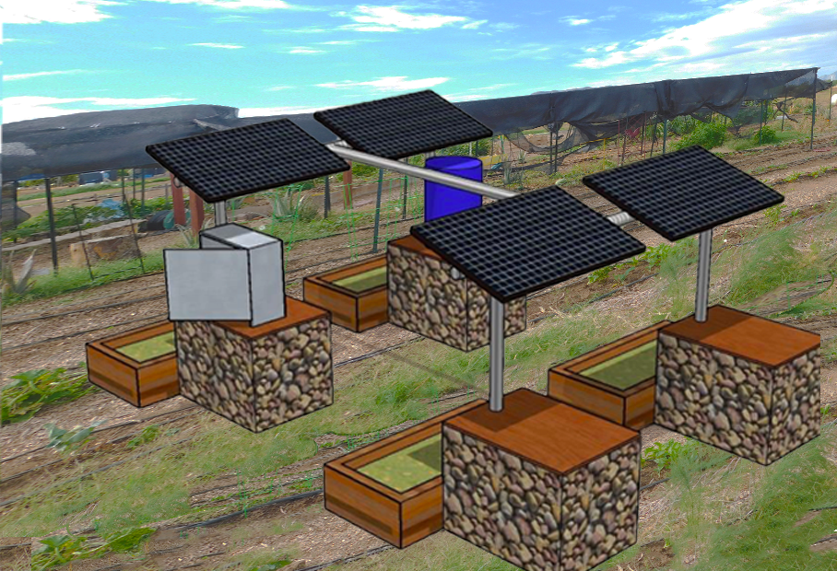

A comprehensive proposal for a solar installation at the nonprofit Project Roots community garden to promote sustainable water and energy resource practices.

Table of contents:

Statement of need .……………………………………………………………………………3
Project rationale …..…………………………………………………………………………...3
Abstract ......……............................................................................................................3 Mission statement ..........................................................................................................3 Community benefits........................................................................................................4 Narrative..........................................................................................................................4
Budget..……………….….................................................................................................6
Design…………………………………………………………………………………………...6
References…….……………............................................................................................7
Detailed budget………………………………………………………………………………...8

Statement of need:
The goal of Project Roots is to provide high-quality fresh food and other essentials to low-income communities, the homeless, and anyone fighting food insecurity, as well as educate children and their families on how to live a healthier and more sustainable lifestyle. They accomplish this by relying on community volunteers and other organizations with similar goals. The solar pergola project is necessary for Project Roots to advance their goals because it would provide them with a more efficient watering system, thereby allowing them to divert volunteer efforts away from watering towards planting and maintaining crops. Additionally, the solar energy created would power batteries that could charge farming equipment, allowing Project Roots to make steps toward becoming self-sufficient.
Project rationale:
Improvement in campus engagement and beautification, as well as providing numerous learning opportunities for the underserved and individuals interested in the incorporation of solar energy in community gardening.
Abstract:
This proposal demonstrates the purpose and benefits of the installation of an agrivoltaics system at the Project Roots community garden. Project Roots is a non-profit community garden that promotes healthy lifestyles, especially in lower-income communities. The garden has had success in the past, including multiple children- and volunteer-run projects, wellness projects, and community outreach. Agrivoltaics is a farming technique that maximizes the use of farmland, utilizing solar panels to provide shade and cover for the crop, preserving water from perspiration as well as obtaining solar energy.
To complete this project, Project Roots would need roughly $15,000. The grant will allow Project Roots to have a renewable energy source, resulting in financial benefits. An agrivoltaics system will also provide a source of shade for the crops, encouraging better crop yield and health in the intense Arizona sun. Overall, the development of an agrivoltaics system at Project Roots will allow them to expand both financially and physically, assisting them in meeting their mission of providing and encouraging a healthy diet to the community.
Mission statement:

“Project Roots nourishes and educates communities in need by promoting a healthier, natural, and more sustainable way of urban living.”

Community benefits:
- Promoting sustainable horticulture opportunities, including education on horticulture practices specific to the South Phoenix area, that are accessible to community members and students in the area.
- Utilizing an unused public lot to grow crops for the community.
- Providing interdisciplinary learning opportunities about solar energy for projects, demonstrations, installations, and collaborations.
- Implementing solar power into Project Roots’ community garden would allow them to become more self-sufficient and lower their carbon footprint.

Narrative:
This proposal seeks to inform Project Roots of the information needed to implement a solar structure for their community farm located in South Phoenix, Arizona. Project Roots is a 501(c)(3) nonprofit organization that focuses on “ways to educate the community about growing their own food through various educational programs” (Project Roots website). They aim to help people struggling with food insecurity get the food they need to nourish themselves, thereby increasing material equity in their neighborhood. Project Roots has numerous programs that serve the greater Phoenix community as well, such as their CSA box project and volunteer gardening opportunities. Our team, a group of University of Arizona Liverman Scholars, have partnered with Project Roots to assist them in working towards getting a solar energy structure built at their South Phoenix community garden.
Community gardens provide many benefits to the surrounding community. They are a great way to educate people about how much effort it takes to produce the food we eat as well as how to grow it for themselves. They also help cultivate relationships between people by bringing together individuals that may not have otherwise met. One of the principal benefits of community gardens is that they often allow unique individuals with different backgrounds and viewpoints to interact. Volunteering at one can be a superb way to expand your social network while also gaining fundamental gardening skills. Project Roots is heavily focused on using community gardening to provide underprivileged people and neighborhoods with the food and nutrients they need to thrive.
Southern Arizona is extremely arid, which can add challenge and complexity. Water is a precious resource in the desert, and conserving it is crucial. The intense summer heat makes working outside during much of the year difficult. A complexity specific to Project Roots is that they do not currently have an energy source on-site that could allow for automatic irrigation and coolers. When our team first connected with the Executive Director of Project Roots, Dionne Washington, she mentioned the possibility of building a solar pergola over a portion of the community garden. We were inspired by her vision, and wanted to help in any way we could.

Dionne graciously gave us a tour of the garden in October of this year, and we were astonished by the effort and passion that has been put into developing this community space. Dionne had previously received a grant that allowed Project Roots to build a shade structure over part of the garden and was curious if there was potential to add solar panels to the structure as a way to have energy available on-site as well as increase crop efficiency. This agricultural system is known as agrivoltaics.
The idea of incorporating agrivoltaics at Project Roots had us intrigued, and Dionne said it would be helpful for the organization if we could aid in the next steps with this effort. Project Roots needed to determine how feasible a solar structure would be and who could help them design and build it. This led us to establish two core goals: 1) Connect Dionne with an expert on agrivoltaics and an engineering company that has experience building solar structures and 2) Provide Dionne with information that could help her obtain funding for the project.
For the first goal, we contacted Dr. Michelle Jordan, an associate professor at Arizona State University that has experience with agrivoltaics, to ask about the feasibility of the project. Dr. Jordan played a key role in getting a solar structure constructed at the Global Academy of Phoenix. She was kind enough to meet with us and provide us with examples of the projects she had worked on, such as the one mentioned above, as well as mentioned an engineering company that we could contact called Veregy. We then met with Dionne to show her examples of structures that may be feasible at Project Roots. One design stood out to her (figure 2). Veregy helped design this model and built the final structure at the Global Academy of Phoenix, so we reached out to one of their Senior Project Managers for information on the needed budget and materials. For the second goal, we decided to develop a grant proposal that Dionne could use to gain funding for the project. The key elements of the grant proposal are a statement of need, an abstract, a mission statement, a list of benefits, a narrative of the process, and a budget.
Beginning with a visit to the Project Roots community garden in early October 2022, to now developing a grant proposal that the nonprofit can leverage to secure future funding to support the creation of a solar structure at the garden, we are thankful to have had this opportunity to collaborate with Project Roots and Dr. Michelle Jordan. We are also grateful for Veregy providing the technical information necessary to embark on a project like this. It will be immensely helpful for Project Roots. Moving forward, we plan to maintain contact with Project Roots and Dr. Michelle Jordan and look forward to seeing the design (fig. 2) come to fruition.

Budget:
Solar Components $2,267.00
Electrical Components $1,051.87
Structural Components $7,530.88
Water Storage and DC-Direct Pumps and Connectors $729.31
Site Preparation, Transportation, and Installation $1,000.00
Design and Fabrication $2,050.00

Total $14,299.75
Note: A more detailed budget sheet can be found on page eight.

Design:
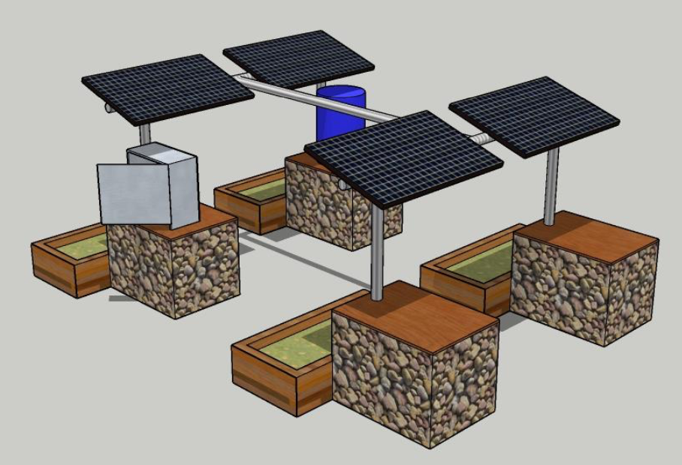
Fig. 2: Model of the solar structure to be constructed at Project Roots.

References:
“Agrivoltaics: What Is It and How Does It Work?” N-Sci Technologies, 6 Jan. 2021, https://nsci.ca/2019/12/05/agrivoltaics-what-is-it-and-how-does-it-work/.
“CSA Box Project.” PROJECT ROOTS, https://www.projectrootsaz.org/produceboxes.
“Diana Liverman Scholars Program.” Arizona Institute for Resilient Environments and Societies, University of Arizona, 1 Nov. 2022, https://environment.arizona.edu/liverman-scholars.
“Energy Optimizations, Delivered.” Veregy, 2022, https://veregy.com/.
“Events/Volunteer Projects.” PROJECT ROOTS, https://www.projectrootsaz.org/volunteer.
“Michelle Jordan.” Knowledge Exchange for Resilience, Arizona State University, https://resilience.asu.edu/jordan.
“Our Story.” PROJECT ROOTS, https://www.projectrootsaz.org/our-story.
“Project Roots.” PROJECT ROOTS, https://www.projectrootsaz.org/.

Detailed budget:
