Overview:

The inspection for this report was performed by Earth Grant interns Jonni Zeman & Alfredo Vasquez. This is a follow-up report from the previous year (March 3, 2022), which was performed by Kelsey Landreville (Restoration Program Manager) and Rachel Loubeau (Natural Resources Specialist). Along with documenting any new observations on the property, we also inspected some of the previous mapped areas which contained invasive species, piles of trash, vandalism, and tire tracks from ATVs.

From what we observed, human impact is still the biggest threat to this site, although we did see some improvement in regard to any evidence of people riding ATVs throughout the property. There was no evidence of any new tire tracks from the last documented observations and the old tracks that were present seem to have washed away with the rains. We did observe and document new piles of trash along with old piles of clothes, so it is possible the people from the surrounding community and people from the homeless encampments that have occurred since the last inspection, are responsible for the damage.

The vegetation on the property consisted of primarily native plant species (Figure 1). We took notice of some interesting and unique ecological features throughout the property that have not been observed on other similar properties We observed a few plant clusters (at least 10) that consisted of one foothill palo verde tree and (several) saguaros growing against each other (Figure 2). There was evidence that the saguaros were outcompeting the palo verde tree/s for water and nutrients. Some of the palo verde trees within those communities were either already dead or beginning to die while the saguaros looked healthy, to say the least.

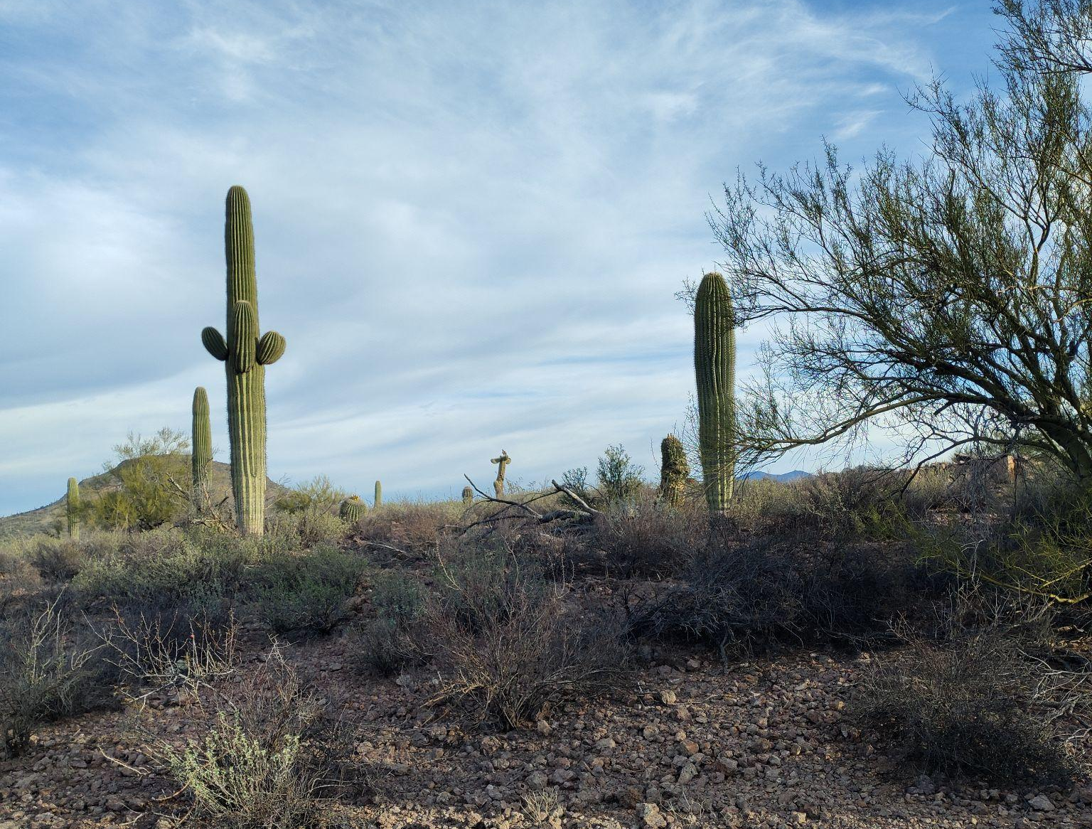
Figure 1. San Juan Trails Property, facing northwest

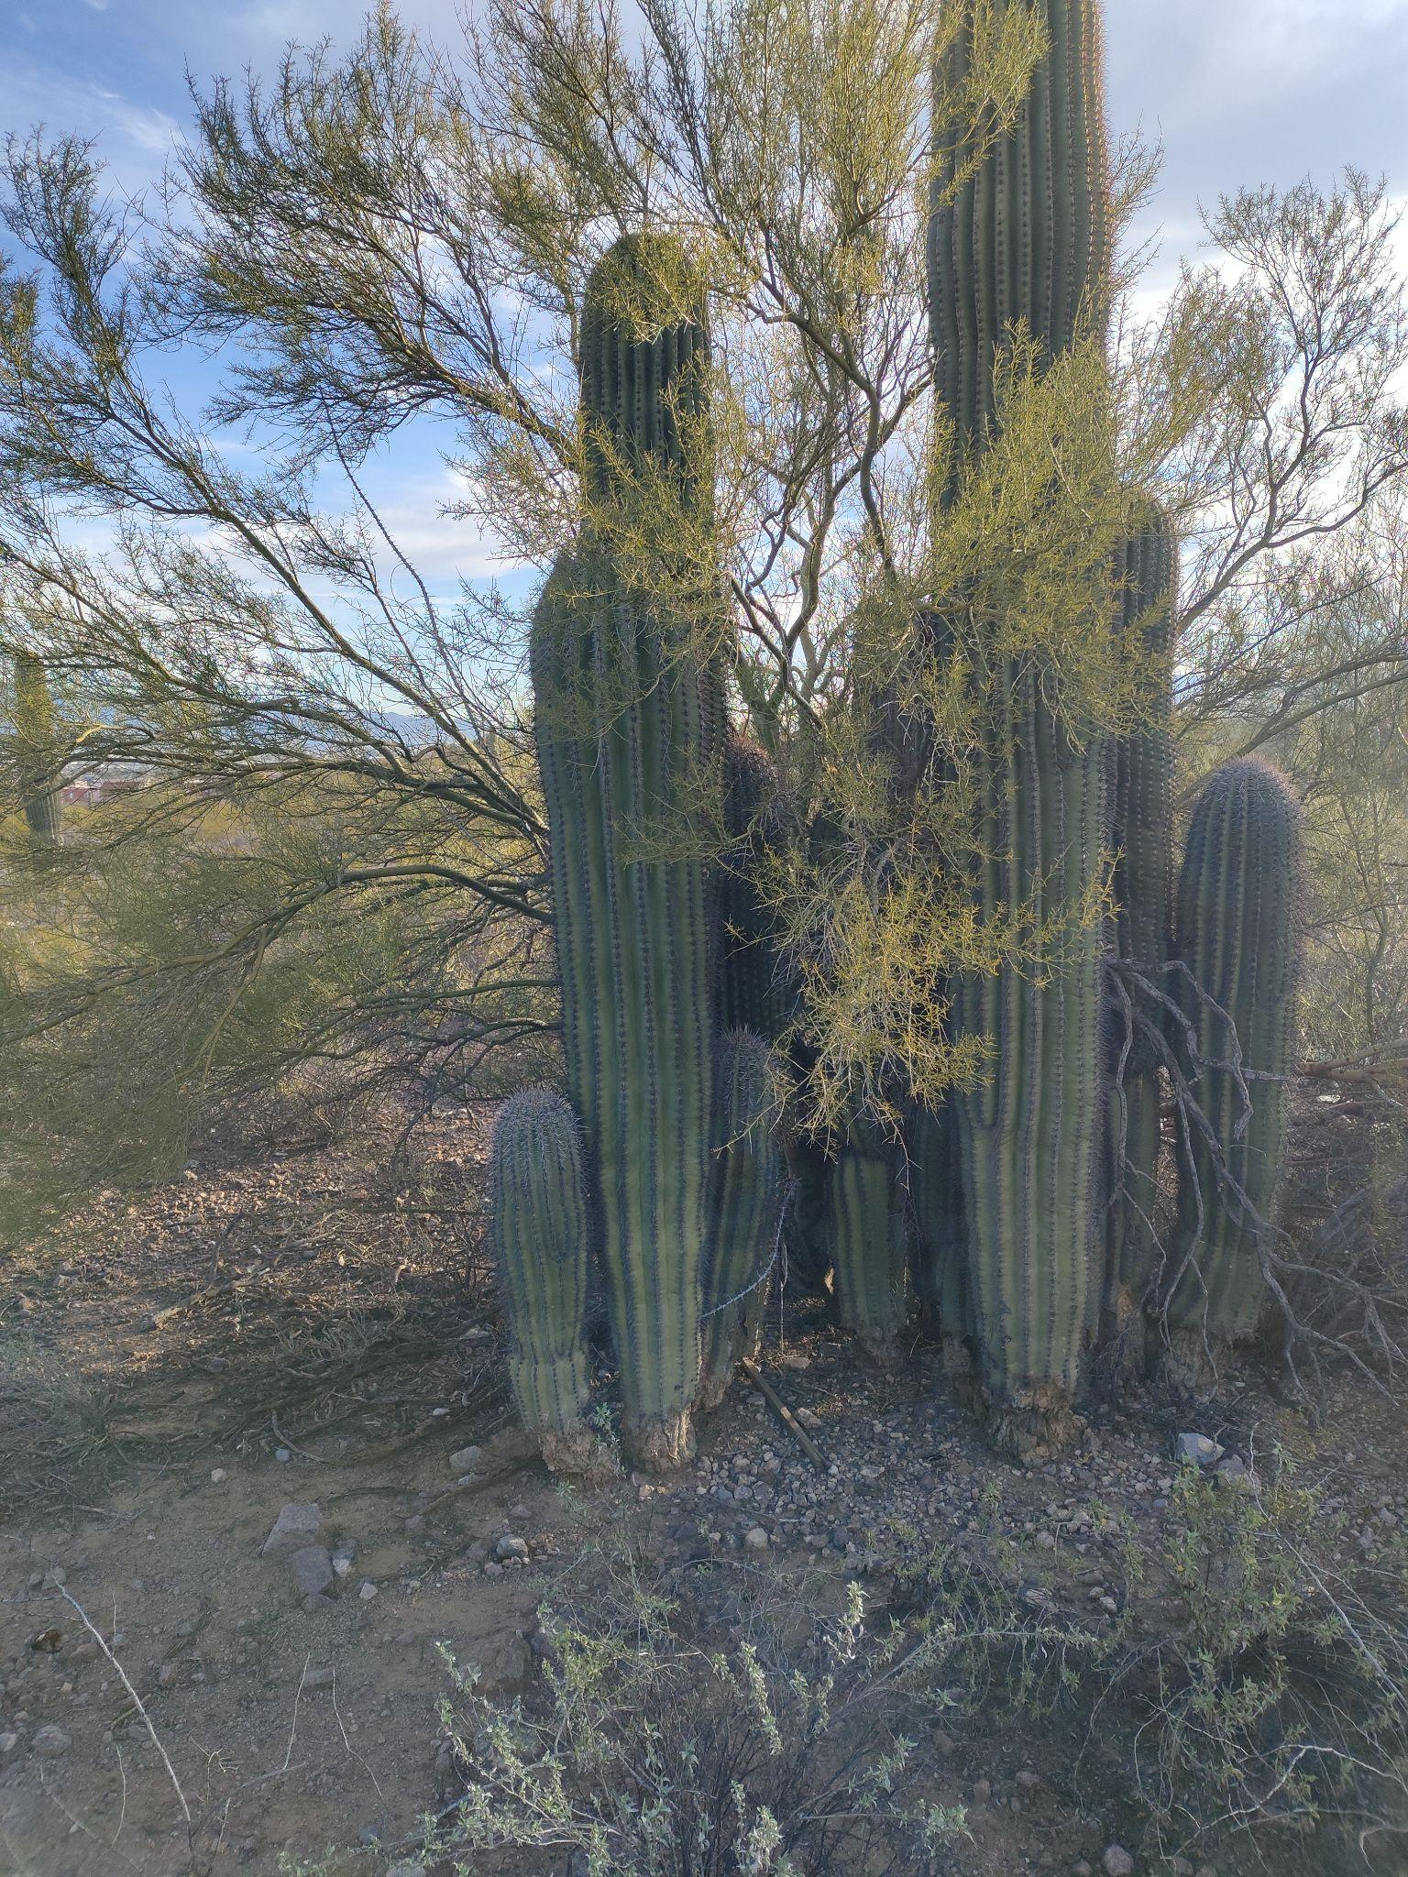

Figure 2. Plant clusters consisting of foothill palo verde and saguaros. These clusters were consistent throughout the property. Coordinates: 32.192, -111.005

Features of Interest/Observations:

One focus for our inspection was to look for newly dumped trash piles of significant size. A significant portion of the property remains littered with glass, ceramics, plastics, clothing, and miscellaneous electronics. Some piles and items previously reported in this site remain in the area. The erosion patterns that were documented in the previous report did not change significantly since the last inspection.

We began our inspection along the southern portion of the property and observed no damage to the fence. However, the Pima County signs were pretty faded due to sun bleaching and may soon need to be replaced. As we inspected the south side of the property and fence, we observed and documented piles of women and children clothing that were not documented before. Within those piles of clothing, there were also suitcases and other forms of travel bags which led us to suspect there were families who were temporarily camping within the property. There were also many toys near the piles of clothing (Figure 3).
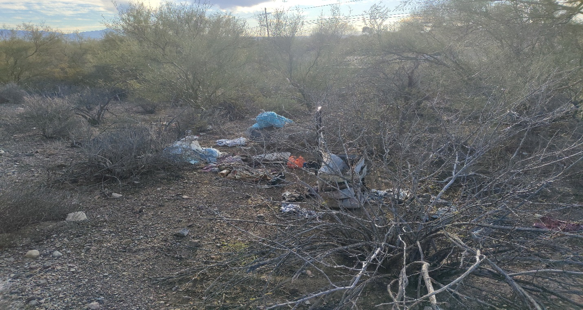
Figure 3. Possible evidence of people using the property as a resting stop for their travels. This of one of three piles of clothing with similar patterns. Coordinates: 32.192, -111.003

We also inspected the dirt piles that were documented from the previous year. We are not certain how much vegetation was already there, but we noticed a good amount of creosote bush growing out of the dirt piles. It seems the piles of dirt are beginning to blend in with the surrounding environment and almost look natural (Figure 4).

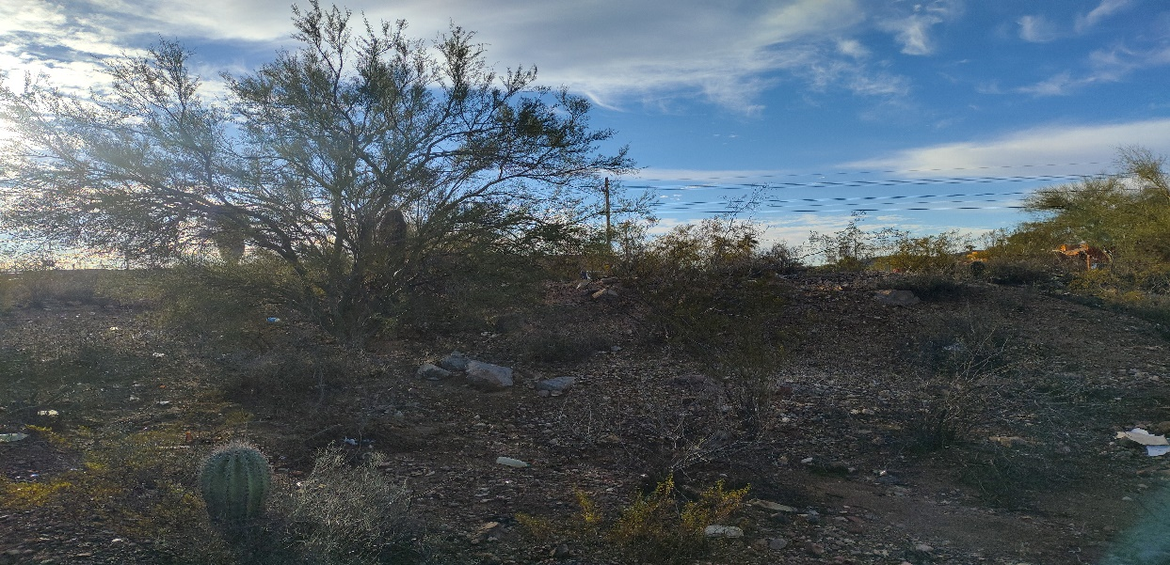
Figure 4. Piles of dirt that were documented on the south portion of the property boundary. Native vegetation is using the dirt mounds to their advantage as seen in this image. Coordinates: 32.193, -111.006

Within the western boundaries of the property, there was also no evidence of anything significant that posed an immediate threat to anyone. Aside from the trash that has accumulated since the last inspection, there was no damage done to the fence nor the signs.

The east side of the property did not have anything significant to document. The fence on the eastern property boundary did not have any signs of damage or vandalism. There was some litter, but nothing hazardous laying around.

The northern boundary still has the fence cut and torn down (Figure 5). There are pieces of barbwire scattered throughout the boundary (Figure 6). We also found an old shopping cart next to another pile of clothing (Figure 7) and some old inflatable mattresses.

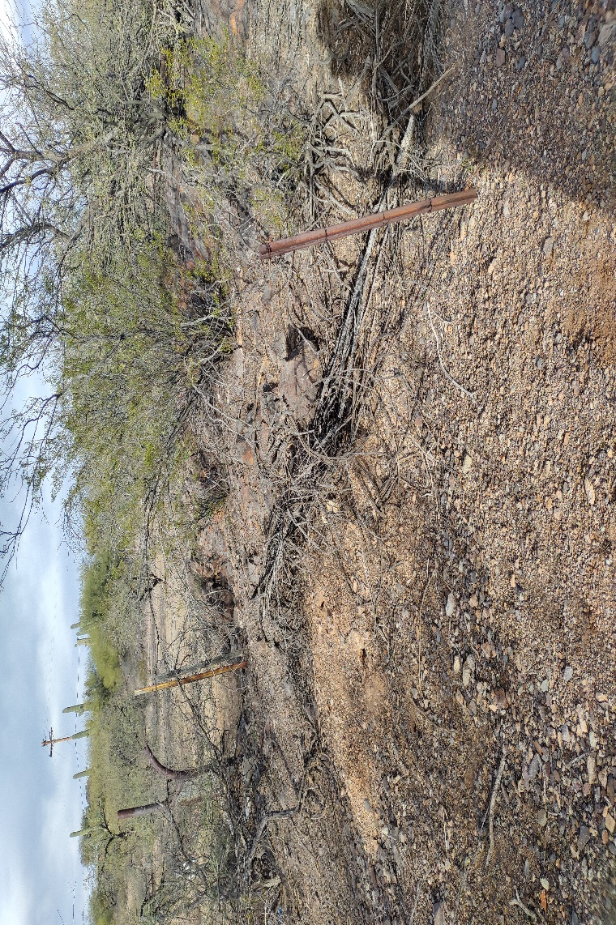
Figure 5. Northern part of the fence that was cut and pushed to the ground for easy access. Coordinates: 32. 193, -111.011

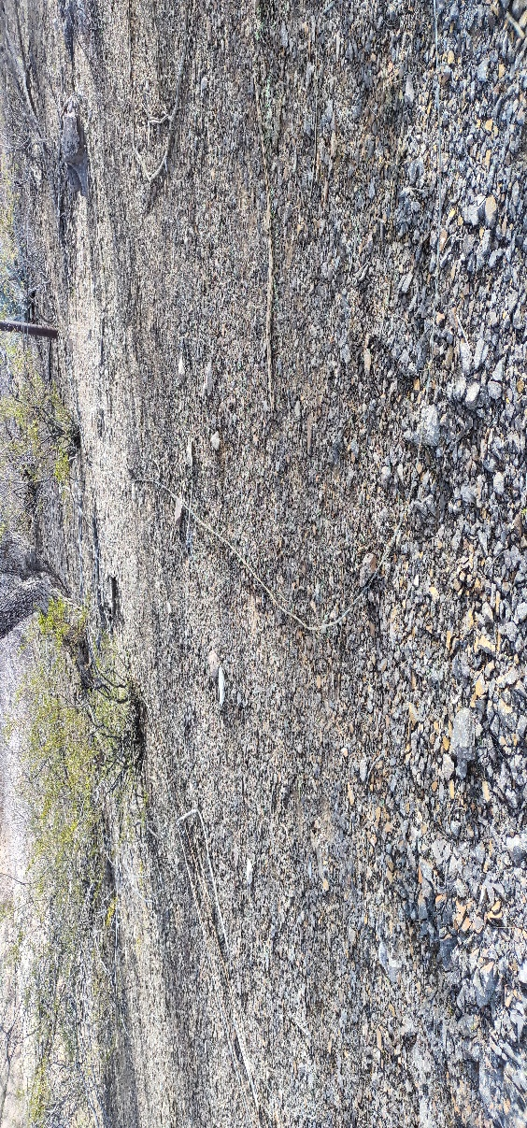
Figure 6. Part of barbwire fence that is scattered on the ground on northern boundary of the property. Coordinates: 32.193, -111.011

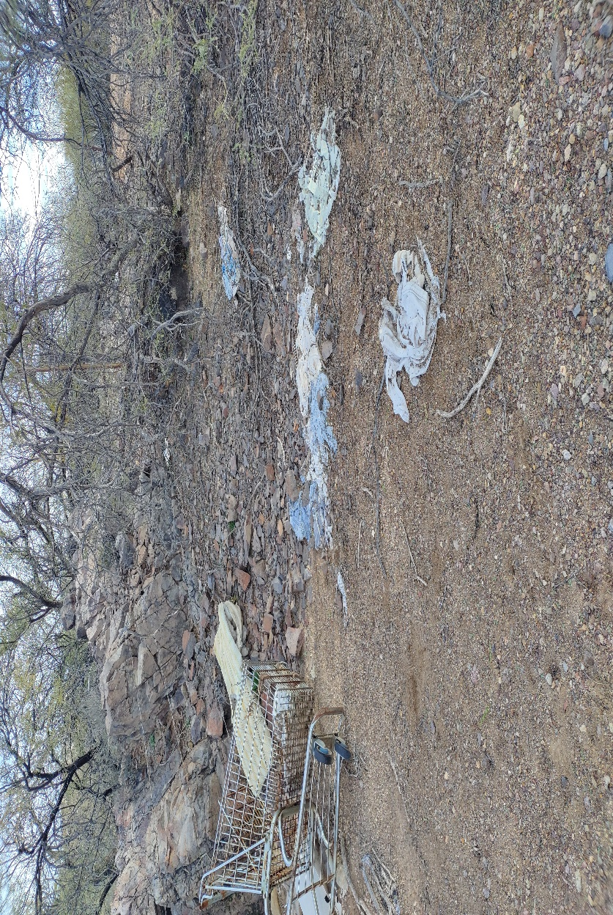
Figure 7. Shopping cart and pile of clothing located on northern boundary of the property. Coordinates: 32.193, -111.011

Invasives:

We did not observe any significant coverage of invasive species on the property. We checked on the treated sites from the previous inspections and did not see any evidence of re-growth from the Lehmann Lovegrass that was manually treated in the southeast corner of the property. However, we did find a few small-sized plants (6cm x 3cm) of buffelgrass in the northwest corner of the property which we manually pulled. The plants we pulled did not have seed-heads, so we did not cover them with a rock.

Wildlife:

Wildlife sightings included rabbits, javelina tracks, packrat middens, coyote tracks, mourning doves, Gila woodpeckers, and cactus wrens. A particularly special sighting was of a very large unidentified hawk, that was so large we thought it was an eagle (Figure 8).
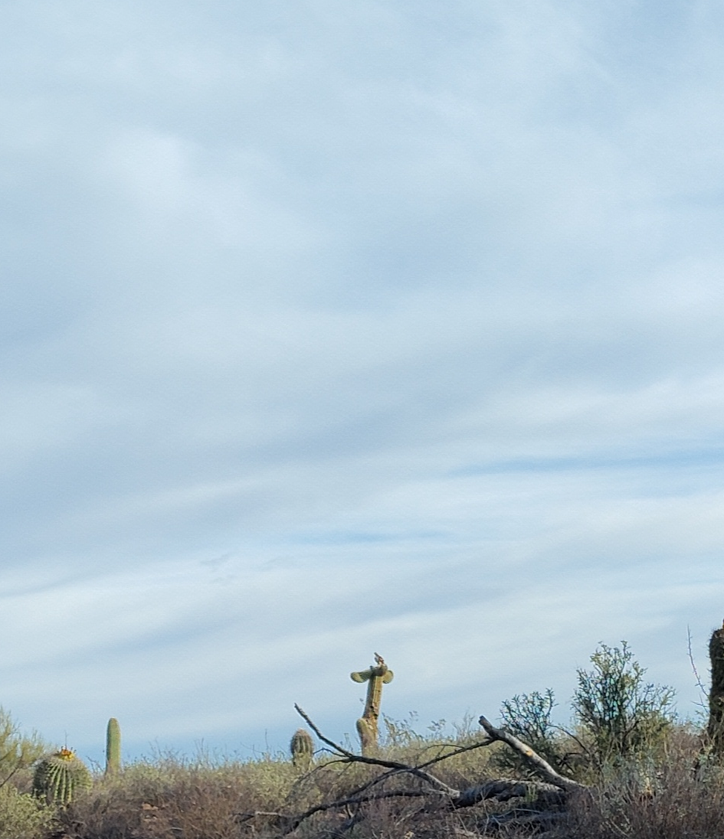
Figure 8. Image of raptor resting on saguaro. Coordinates: 32.193, -111.006

Species List:

Triangle leaf bursage | Ambrosia deltoidea
Foothills palo verde | Parkinsonia microphylla
Creosote | Larrea tridentata
Mistletoe cactus | Rhipsalis baccifera
Sweet acacia | Vachellia farnesiana
Fluff grass | Dasyochloa pulchella
White thorn acacia | Vachellia constricta
Desert senna | Senna covesii
Crucifixion thorn | Castela emoryi
Fishhook barrel cactus | Ferocactus wislizeni
Saguaro | Carnegiea gigantea
Buffelgrass | Cenchrus ciliaris
Chain fruit cholla | Cylindropuntia fulgida
Three awn | Aristida adscensionis
Stag horn cholla | Cylindropuntia acanthocarpa
Six weeks grama | Bouteloua barbata
Snake weed | Gutierrezia sarothrae
Ocotillo | Fouquieria splendens
Prickly pear | Opuntia engelmannii
Desert marigold | Baileya multiradiata
Honey mesquite | Prosopis glandulosa
Silver cholla | Cylindropuntia echinocarpa
Christmas tree cactus | Schlumbergera bridgesii
Velvet mesquite | Prosopis velutina
Pincushion cactus | Mammillaria spinosissima
Hedgehog cactus | Echinocereus engelmannii
Cat claw acacia | Senegalia greggii
Blue palo verde | Parkinsonia florida
Gray thorn | Ziziphus obtusifolia
Spider grass | Aristida ternipes

Suggested Management Actions:

- The fence in the northern boundary of the property needs to get fixed and removed off the ground in order for any person and/or wildlife get tangled in the mess.
- Replace faded signs on the southern side of the fence.
- Organize a trash clean up throughout the property.
- Follow-up on invasive species control within the property
- Create structure for erosion control.

